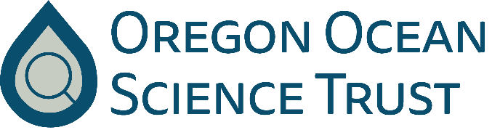
Agenda
Thursday, 30 October 2025 | NOON–3:00 PM

Meeting will be in-person: Hatfield Marine Science Center | Guin Library | Barry Fisher Room
GoToMeeting: https://meet.goto.com/createstrat/oregonoceansciencetrust
Call in information: (571) 317-3112 | Access Code: 438-756-733

NOON–12:30PM Welcome, introductions, opening comments, approval of previous meeting summary – Chair Laura Anderson

12:10PM–12:45PM Trust ocean and coastal grant project presentation
Olympia Oyster Growth and Survival with Climate Change: Space for Time Field Experiments (G. Waldbusser, Oregon State University)
12:45PM–1:45PM Trust Administrative Items
- Update on RFP for OOST administrative support (Cristen, Karina, Jean)
- Process for appointments to Land Board/staggered terms (Jean)
- Administrative rate (Jean)
- Final Annual Report (Laura)
- Status of Trust-funded grant projects to date (Lisa)
- Review of draft bylaw changes/amendments (Karina, Lisa)
- Review of Trust budget (Lisa)
- Fundraising updates (Lisa)

1:45PM–2:00PM BREAK

2:00PM–2:30PM Board Member Open Mic
- An opportunity for Board members to discuss topics of interest
2:30PM–2:45PM The West Coast Ocean Science Agenda
- Update, discussion, and key next steps re: the West Coast Ocean Science Agenda (Guest: Liz Whiteman, California OST)
  - Advisory Committee, fundraising, subregional convenings, next steps
2:45PM–2:55PM Public Comment

2:55PM–3:00PM Other business, closing remarks, and Adjourn

Agenda items and times are subject to change. DSL will make reasonable accommodation for people with disabilities. Please notify Oregon Relay Service (1-800-735-2900) at least 5 business days before meeting.

